Network graph – Supplementary
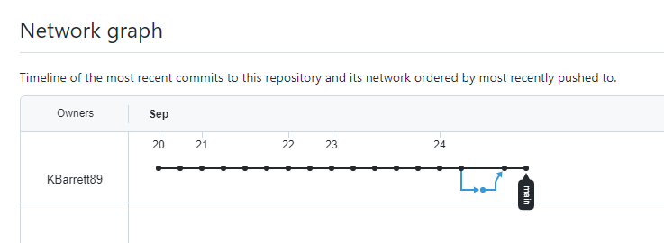

Network graph – NGINX
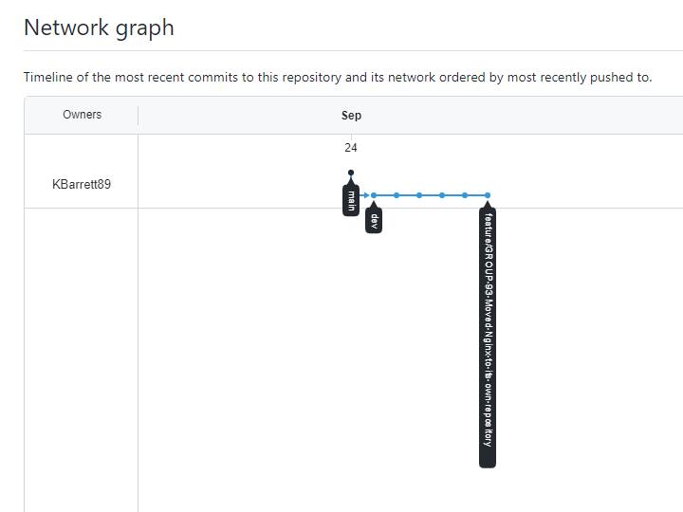

MERGE requests
